**The Influence Of The Location Of Concrete Joints And Longitudinal Reinforcement On T-Beams At A Distance Of A Quarter Of The Span**

**Vega Aditama*1a, Setyawanto Agus Rany*2**

|  |  |
| --- | --- |
| **Submit:**  20 Maret 2025 | **\**1*** *Departemen Teknik Sipil, Fakultas Teknik Sipil dan Perencanaan, Institut Teknologi Nasional, Kota Malang, Indonesia, , vegaaditama@gmail.com* |
| **Review:**  28 Maret 2025 | ***\*2*** *Departemen Teknik Sipil, Fakultas Teknik Sipil dan Perencanaan, Institut Teknologi Nasional, Kota Malang, Indonesia, , insinyurmaju@gmail.com* |
| **Revised:**  7 April 2025 |  |
| **Published :**  6 Mei 2025 | ***aCorresponding Author:*** *vegaaditama@gmail.com* |

***Abstract***

*The purpose of this study is to compare continuous beams (CB) with beams with concrete and reinforcement joints spaced at 1/4 span to analyze the flexural and shear behavior of reinforced concrete T-beams. The bending moment, shear strength, and strain on each beam are measured experimentally as part of the procedures. The test findings demonstrate that the T-beam with no joints has a larger flexural capacity, with a maximum bending moment of 28905926.28 Nmm and beginning cracking at a weight of 1543.08 kg.*

***Keywords: t-beam, concrete joint, longitudinal reinforcement, bending strength, shear strength***

**INTRODUCTION**

The construction of safe and earthquake-resistant infrastructure is one of the main challenges in structural design in Indonesia, which is known as a country with a high level of seismic activity. In this context, T-beams as structural elements play an important role in supporting loads and maintaining the stability of buildings. Therefore, a deep understanding of the behaviour of T-beams, particularly concerning concrete joints and longitudinal reinforcement, is essential to ensure the safety and reliability of the structure. This research aims to explore the influence of the placement of concrete joints and longitudinal reinforcement on T-beams regarding strength and deflection, with a focus on joints located at a distance of 1/4 span[4][8].

The connection between old and new concrete often becomes a weak point in reinforced concrete structures, which can affect the overall performance of the beam. According to SNI 03-2847-2002, the design of reinforced concrete structures must consider the proper use of transverse and longitudinal reinforcement to achieve appropriate values of flexural, shear, and deflection[2]. This research will compare T-beams without joints to T-beams with joints at a distance of 1/4 span to identify differences in flexural strength, shear strength, and deflection behaviour. Thus, the research results are expected to make a significant contribution to the development of better and safer structural designs[6].

Through systematic laboratory testing, this research will analyse experimental data that includes measurements of maximum load, deflection, and crack patterns occurring in T-beams. The results of this research are expected not only to provide insights into the influence of joints on the performance of T-beams but also to offer practical recommendations for planners and project implementers in designing more efficient and dynamic load-resistant reinforced concrete structures, especially in earthquake-prone areas. Thus, this research contributes to efforts to enhance the safety and resilience of buildings in Indonesia.

**METHODOLOGY**

1. **Methods**

In this study, the test specimens used consist of concrete cylinders measuring 150 x 300 mm and "T" beams with specific dimensions. The "T" beam has a height (hf) of 80 mm, a width (bw) of 150 mm, a total height (h) of 250 mm, and an external width (be) of 550 mm. There are two variations in the construction of this beam: first, three samples of beams without joints, and second, two samples of beams with a concrete and reinforcement joint distance set at ¼ span. This variation aims to evaluate the influence of the joint on the strength and behaviour of the beam during testing.

The process of making the "T" beam test specimen begins with the creation of six molds, three of which are used for the unjointed beams and the other three for the jointed beams. Before casting, the reinforcement to be used is prepared, with main reinforcement having a diameter of 7.5 mm for the tension and compression areas, and stirrups with a diameter of 4.5 mm. After the formwork is ready, the concrete mix is poured into the mold that has been cleaned and oiled. To prevent leaks, each corner in the mold is sealed with tape and wet cement paper. The compaction process is carried out by tapping the sides of the formwork with a hammer to ensure air bubbles are released. After the concrete hardens, the mold is opened to obtain the test specimen ready for curing.

The curing of test specimens is very important to ensure the quality of the produced concrete. In this study, the curing was carried out by evenly watering the test beams with water until one day before testing, over a period of 28 days. This curing method aims to maintain the moisture of the concrete, which is crucial for the cement hydration process. With proper maintenance, the strength of the concrete can increase, resulting in a stronger and more durable material.

After the manufacturing and maintenance processes are completed, testing is conducted to measure the tensile strength of steel, the compressive strength of cylinders, and the flexural strength of beams. The tensile strength testing of the steel reinforcement is conducted in the Material Testing Laboratory, where the data collected includes the maximum load, fracture load, and initial yield point[5][10]. For the compressive strength test of the cylinder, the cylindrical test specimen is placed on the compression testing machine, and the load is applied gradually until the specimen fails. The compressive strength of concrete is calculated by dividing the ultimate load achieved by the pressed surface area.

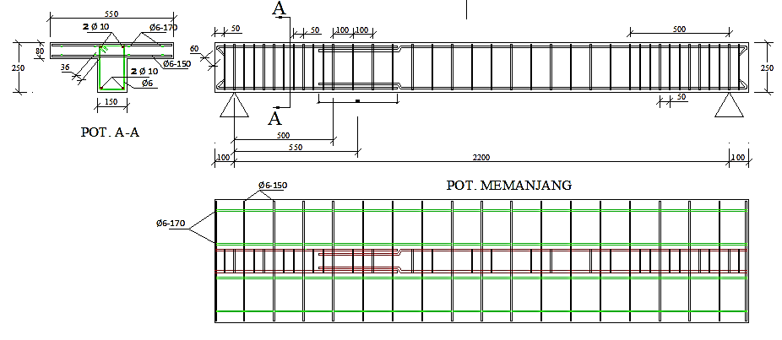

Figure 1. Position of a quarter of beam

The control variable used in this study is the difference between beams with joints at a quarter span and those without joints[3][9][12], as illustrated in Figure 1. Next, the flexural strength test of the beam is conducted by placing the test specimen on the frame and using a hydraulic jack to apply a transverse force. The load measuring instrument, namely the proving ring, is used to monitor the applied load. During the testing, the deflection is recorded using a digital reading device (MVD Amplifier) connected to a digital dial (LVDT). The testing process is carried out in stages until a certain limit is reached, where the cracks and deflections that occur are recorded for further analysis. The variables measured during the deflection test will provide important information about the behavior of the beam under load, allowing for the evaluation of the strength and durability of the tested structure.



Figure 2. Deflection testing process

1. **Concrete Mix Design**

The composition of the concrete mix used in this study includes the type of cement, aggregates, and water. Testing is conducted to ensure that the mixture meets the established quality standards[1]. The concrete mix is designed to achieve the desired compressive strength of 354 MPa using the appropriate mix design method.

Table 1. Composition of Concrete Mix from Mix Design

|  |  |  |  |  |  |  |
| --- | --- | --- | --- | --- | --- | --- |
| Material | Type / Size | Solid | Specific | Proportion | Material | Remarks |
| Volume | Gravity | Content |
| (M³) | (Ton/M³) | (%) | (Kg/M³) |
| Cement | Type - 1 | 0,111 | 3,14 | - | 350 | Ex. PT Semen Gresik |
| Water | - | 0,180 | 1,00 | - | 180 | - |
| Filler | Fly Ash | 0,033 | 2,68 | 20,00 | 88 | Paiton |
| Aggregate | Sand | 0,315 | 2,68 | 48,49 | 845 | Lumajang |
|  | 10 ˗ 20 | 0,230 | 2,54 | 33,48 | 584 | Pandaan |
|  | 20 ˗ 30 | 0,122 | 2,58 | 18,03 | 314 | Pandaan |
| Admixture | Type - D | - | - | 0,250 | 1,10 | Dosage % by Cement Content |
| Water |  | 0,001 | - | - | - |  |
| Total Solid Volume | 1,0 | (M³) |  | Concrete Density | 2,362 | (KG/M³) |

1. **Equations Used**

These formulas are used to analyze the flexural and shear behavior of reinforced T-beams in this study, both for concentrated loads and uniformly distributed loads [7][11].

Bending Moment (M)

For the bending moment on the beam:

$M=\frac{1}{8}qL^{2}+\frac{1}{4}PL$ (1)

where:

( $q$) = uniform load (N/mm)

( $P$) = centralized load (N)

( $L$) = length of the beam (mm)

Moment when it First Cracked ($M_{c}r$)

$M_{cr}=f_{r}⋅I_{g}⋅Y_{t}$ (2)

where:

( $f_{r}=0.75\sqrt{f^{'}c}$) (Modulus of rupture of concrete)

( $I_{g}$) = gross section inertia (mm4)

( ) = distance from the center of the gross cross-section (mm)

Momen of Inertia of a Cracked Section ($I_{c}r$)

$$I_{cr}=\frac{1}{12}bec^{3}+bec{\left(\frac{1}{2}c\right)}^{2}+ηA_{s}{\left(c-d_{1}^{'}\right)}^{2}-A_{s}{\left(c-d_{1}^{'}\right)}^{2}+$$

$ηA_{s}{\left(c-d_{2}^{'}\right)}^{2}-A_{s}{\left(c-d_{2}^{'}\right)}^{2}+ηA_{s}{\left(d_{1}^{'}-c\right)}^{2}-ηA_{s}{\left(d_{2}^{'}-c\right)}^{2}$ (3)

Momen of Inertia of The Entire Cross-section ($I_{g}$)

$I_{g}=\frac{bh^{3}}{12}$ (4)

where:

( $b$) = width of the beam(mm)

( $h$) = height of the beam (mm)

Total Deflection (Δ)

$Δ=\frac{P{\left(ln\right)}^{3}}{48E_{c}I_{e}}+\frac{5ql^{4}}{384E_{c}I_{e}}$ (5)

where:

( $P$) = centralized load (N)

( $l$) = length of the beam (mm)

( $E_{c}$) = concrete modulus of elasticity (MPa)

( $I_{e}$) = effective moment of inertia (mm4)

( ) = uniform load (N/mm)

1. **Results of Theoretical Analysis**

The data obtained for the calculations in this study comes from the initial experimental results, including the compressive strength of concrete and the tensile strength of steel that were tested. The test specimen used is a reinforced concrete "T" beam with the following specifications: the length of the beam reaches 2200 mm, the height of the beam (h) is 250 mm, the thickness of the plate (hf) is 80 mm, and the width of the flange (be) is 550 mm. The overall dimensions of the beam are ((625 x 80) + (170 x 150)) mm x 2200 mm. The quality of concrete used in this study is 354 MPa, while the quality of the Ø7.5 rebar has a yield strength (fy) of 461 MPa, and the quality of the Ø4.5 rebar has a fy of 335 MPa. The main reinforcement used is Ø7.5 mm, while the stirrup reinforcement used is Ø4.5 mm. The concrete cover on this beam is 20 mm. Additionally, the modulus of elasticity of steel (Es) used in the calculations is 200,000 MPa, by SNI 03-2847-2002, article 10.5.2, page 54. The maximum concrete strain (Єc’) is set at 0.003 MPa, referring to SNI 03-2847-2002, article 12.2.3.

Table 2. Results of Moment Control and Compression Reinforcement Control for Reinforced Concrete "T" Beams:

|  |  |  |  |  |
| --- | --- | --- | --- | --- |
| Aspect | Parameters | Values | Yield Limit | Description |
| Moment Control | Moment Nominal (Mn) | 28,905,926.277 Nmm |  | Accepted |
|  | Load Moment (Mr) | 28,905,926.277 Nmm |  | Accepted |
| Compression Reinforcement Control | Tensile Stress 1 (fs1) | 522.135 Mpa | 335 Mpa | Accepted |
|  | Tensile Stress 2 (fs2) | 585.058 Mpa | 461 Mpa | Accepted |
|  | Tensile Stress 3 (fs3) | 1633.78 Mpa | 335 Mpa | Accepted |

The results of the moment control and compression reinforcement control indicate that this reinforced concrete "T" beam meets the requirements for both aspects. From the calculations, a nominal moment (Mn) value of 28,905,926.277 Nmm was obtained, which is greater than the moment produced by the load (Mr), which also has a value of 28,905,926.277 Nmm. This shows that the beam's capacity to withstand the moment is more than sufficient for the applied load, making the beam safe in terms of moment control.



Figure 3. Graph of Load-Deflection Relationship

The graph above shows the relationship between load (in kg) and deflection (in mm) of a material, with the Y-axis representing the load ranging from 0 to over 5000 kg, and the X-axis showing deflection from 0 to 5 mm. The theoretical bending curve depicted by the blue line shows that bending increases with the addition of load. There is a dashed red horizontal line at a load of 5059.459 kg indicating the theoretical maximum load without failure. At a load of 1500 kg, point P's initial crack shows a material deflection of 0.38 mm, while the maximum recorded deflection is 4.48 mm, illustrating the maximum deformation before failure. This graph is important for structural analysis in determining the strength and elasticity characteristics of the material under a certain load.

**RESULTS AND DISCUSSION**

1. **Results of the Deflection Experiment Analysis**

The deflection experimental analysis in this study uses the design parameters of a reinforced concrete T-beam, namely a length of 2200 mm, a height of 250 mm, a slab thickness of 80 mm, and a flange width of 550 mm. The concrete cover has a thickness of 20 mm, with a concrete quality of 40.415 MPa. The steel quality for the main reinforcement with a diameter of 7.5 mm is 461 MPa, while the stirrup reinforcement with a diameter of 4.5 mm has a quality of 335 MPa.

The analysis of deflection experiments on T-beams is a crucial aspect in understanding the behavior of reinforced concrete structures under load. In this study, three types of unjointed T-beams were tested, namely Unjointed T-beam A (BTS-A), Unjointed T-beam B (BTS-B), and Unjointed T-beam C (BTS-C). Each type of beam was tested to determine the deflection that occurred at various load levels, and the test results provided insights into the flexural capacity of each beam.

* **T Beam with a Joint Spacing of 1/4 (B-1/4) A**

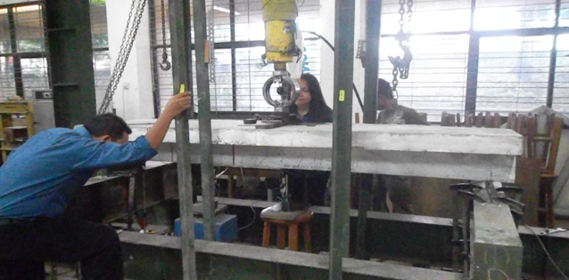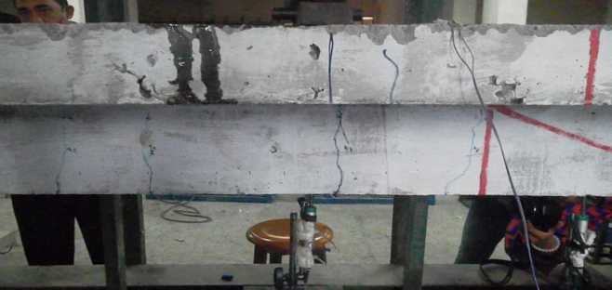

Figure 4. Flexural Strength Testing and Crack Pattern of Beams with Joint Spacing (1/4) A

Fig. 4 shows beam B-1/4 A is designed with concrete joints and reinforcement placed at 1/4 span (550 mm from the end of the beam). Using main reinforcement Ø7.5 mm (fy = 461 MPa) and stirrups Ø4.5 mm (fy = 335 MPa), this beam reached a peak load of 2865.72 Kg with a mid-span deflection of 4.38 mm. The first crack appeared at a load of 881.76 Kg (deflection of 0.56 mm), concentrated in the joint area due to the concentration of bending stress. As the load increased, the crack propagated diagonally to the mid-span with a width of ±1 mm, indicating that the joint successfully reduced local deformation. However, slip between the concrete and reinforcement occurs at loads above 2500 Kg, reducing the effectiveness of load transfer and causing the final capacity to be only 56% of the theoretical prediction (5059.46 Kg). This performance indicates that although the 1/4 span connection increases stiffness, the imperfection of the concrete-rebar bond becomes the main limiting factor.

* **T Beam with a Joint Spacing of 1/4 (B-1/4) B**

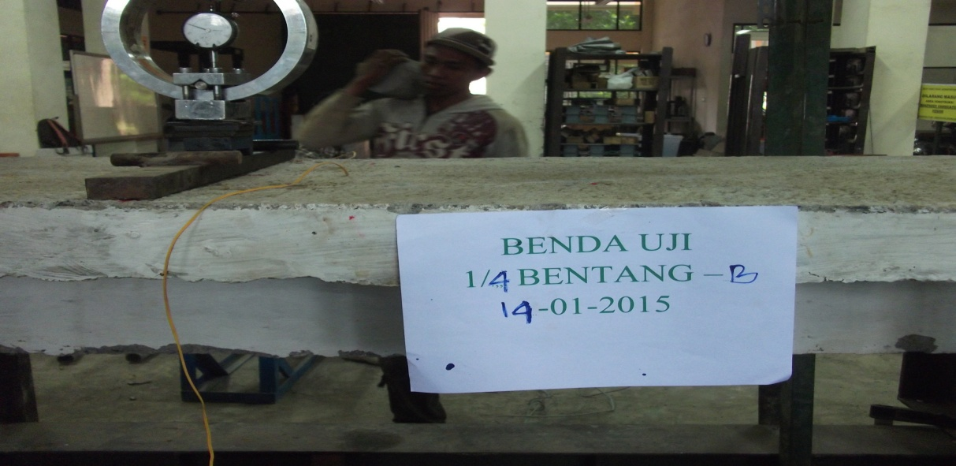 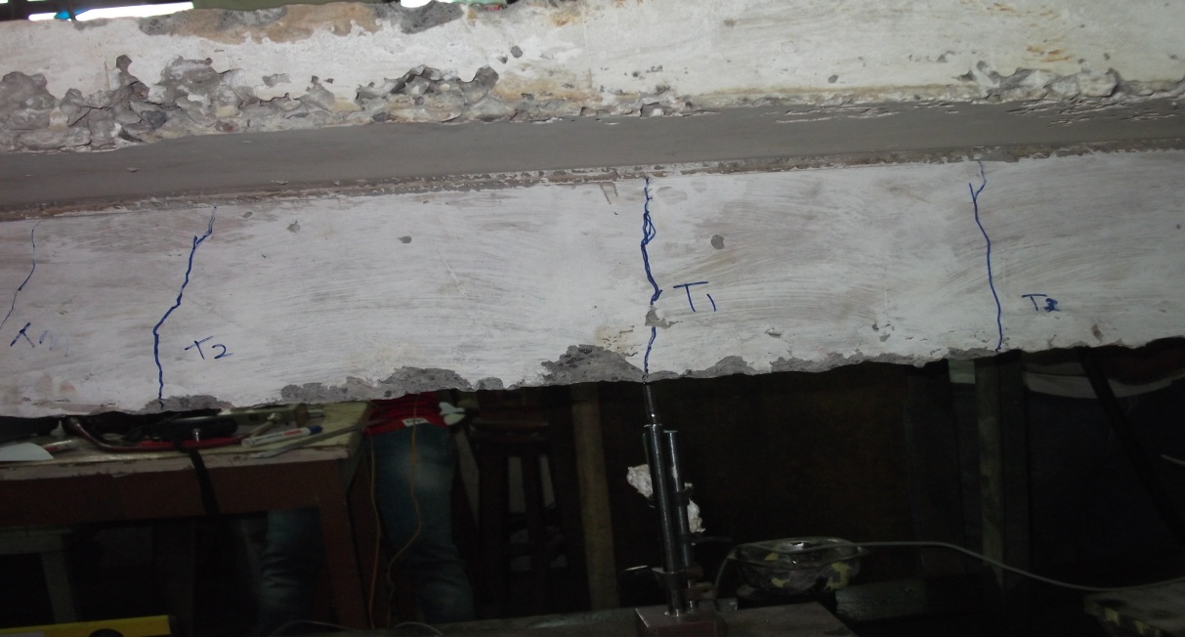

Figure 5. Flexural Strength Testing and Crack Pattern of Beams with Joint Spacing (1/4) B

Fig. 5 shows beam B-1/4 B has a joint configuration similar to B-1/4 A, but with a lower stirrup density (spacing 150 mm vs. 100 mm in B-1/4 C). The test results show a peak load of 2755.50 Kg and a deflection of 6.18 mm, with initial cracking at 1487.97 Kg (deflection of 2.13 mm). Higher deflection is caused by uneven crack distribution and significant steel-concrete slip in the joint area. Wide diagonal cracks (±1.3 mm) formed in the mid-span, indicating shear failure due to insufficient stirrup reinforcement to resist lateral deformation. In the post-peak phase, the beam experienced a drastic reduction in load capacity until it collapsed at 2479.95 Kg (deflection 8.17 mm). This result confirms that inadequate stirrup spacing reduces the joint's ability to distribute the load, thereby increasing the risk of collapse.

* **T Beam with a Joint Spacing of 1/4 C (B-1/4)**

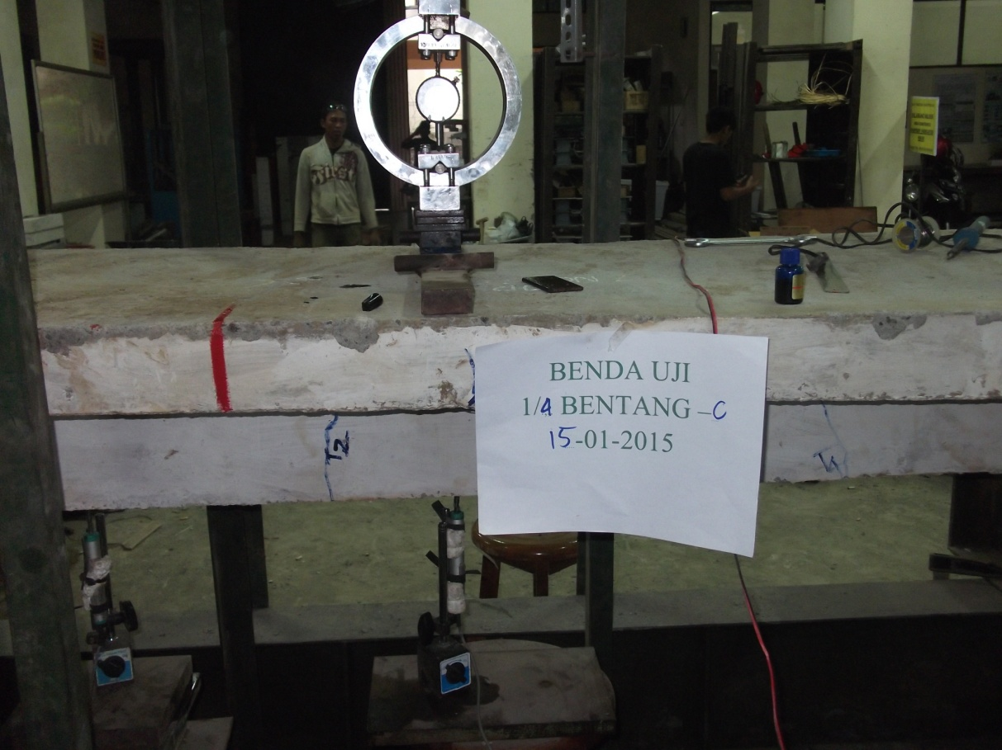 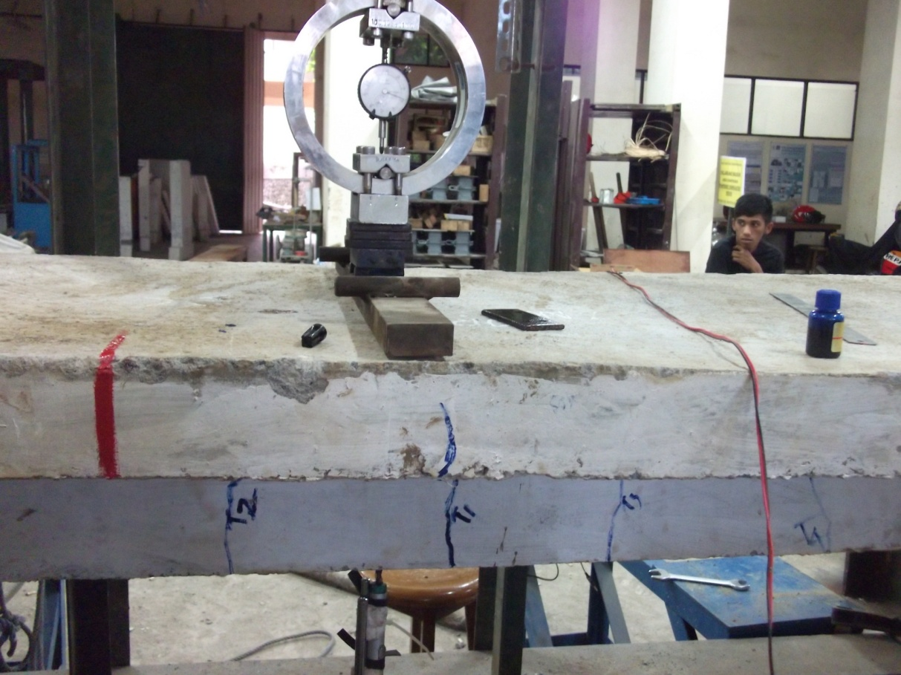

Figure 6. Flexural Strength Testing and Crack Pattern of Beams with Joint Spacing 1/4 C (B-1/4)

Fig. 6 shows beam B-1/4 C is an optimized variant with closely spaced stirrups (100 mm spacing) and controlled concrete curing techniques. This beam reached the highest peak load (2975.94 Kg) and minimal deflection (3.66 mm), with initial cracking at 1653.30 Kg (deflection 1.03 mm). The crack pattern is evenly distributed along the span, with a main crack of approximately ±1.5 mm in the joint area. The optimization of this joint increases the torsional stiffness and reduces the slip between the reinforcement and concrete, bringing the load capacity close to 59% of the theoretical value. In the failure phase, the beam remained stable with a gradual load reduction up to 2865.72 Kg (deflection 3.93 mm), demonstrating excellent ductile behavior. This success is due to a combination of precision joint design, high-quality materials, and an optimal curing process that minimizes internal defects.

1. **Comparison of BTS Experimental Results, 1/4 Span Joint and the Distance of Concrete and Reinforcement Joints (1/4) on Mid-Span Deflection**

The BTS beam and the 1/4 span connection only reached 56% and 57% of the theoretical load capacity, with deflections 91% and 8% above predictions. Beam B-1/4 C excels with 59% theoretical capacity (2,975.94 Kg) and a deflection of 3.66 mm (16% better than the average joint).

Table 3. Comparison of BTS Experimental Results, 1/4 Span Joint and the Distance of Concrete and Reinforcement Joints (1/4) on Mid-Span Deflection

|  |  |  |  |  |
| --- | --- | --- | --- | --- |
| Parameters | BTS | Joints 1/4 Span | B-1/4 C | Theory |
| Peak Load (Kg) | 2.838,17 (56%) | 2.865,72 (57%) | 2.975,94 (59%) | 5.059,46 (100%) |
| Deflection (mm) | 8,40 (+91%) | 4,74 (+8%) | 3,66 (-16%) | 4,39 (100%) |

1. **Results of the Flexural Strength and Shear Strength Experiment Analysis**

The results of the flexural and shear strength experiments indicate that the unconnected T-beam (BTS) experienced its initial crack at a load of 1543.08 kg with a final crack width of 2.1 mm. In contrast, T-beams with a connection spacing of 1/4 span exhibited lower performance, where beam B-1/4 A showed an initial crack at only 881.76 kg and a final crack width of 1 mm, with maximum bending moments of 27,550,000 Nmm, 27,000,000 Nmm, and 26,000,000 Nmm for B-1/4 A, B-1/4 B, and B-1/4 C respectively—values lower than that of the unjointed beam, which reached up to 28,905,926.28 Nmm. The shear strength for the 1/4 span jointed beam was 30,000 N, indicating that the joint reduces shear capacity and may compromise structural stability due to increased stress concentrations. Similarly, a T-beam with a 1/4 connection at mid-span recorded a maximum bending moment of 26,500,000 Nmm, reaffirming the weakening effect of joints. The comparison between theoretical and experimental values, with a theoretical bending moment of 50,594.59 Nmm for the unjointed beam, shows good alignment and validates the calculation model. Overall, the analysis demonstrates that the presence of joints significantly reduces both the flexural and shear capacity of T-beams, emphasizing the need for careful joint design in structural engineering.

**Results of Strain Gauge Observations**

Table 4. Results of Strain Gauge Observations

|  |  |  |
| --- | --- | --- |
| Spesimens | Load (Kg) | Strain (m) |
| Beam Without Joints A (BTS-A) | 1432,86 | 0,000681 |
| Beam Without Joints B (BTS-B) | 1212,42 | 0,000538 |
| Beam Without Joint C (BTS-C) | 1763,52 | 0,000695 |
| T Beam with 1/4 A Connection | 1487,97 | 0,016118 |
| T Beam with 1/4 B Connection | 1487,97 | 0,027165 |
| T Beam with 1/4 C Connection | 1543,08 | 0,057545 |

Based on table 6, the results of strain gauge observations for various test specimens of reinforced concrete T-beams, both those without joints and those with joints spaced at 1/4 span. In the unbonded beam A (BTS-A), the applied load of 1432.86 Kg resulted in a measured strain of 0.000681 m, indicating good performance in load-bearing. The beam without joint B (BTS-B) shows lower strain, namely 0.000538 m at a load of 1212.42 Kg, while the beam without joint C (BTS-C) recorded a strain of 0.000695 m at a load of 1763.52 Kg. On the other hand, the T-beam with a 1/4 A joint experienced a significant increase in strain, with a measured strain of 0.016118 m at a load of 1487.97 Kg. The T-beam with joint 1/4 B showed even higher strain, namely 0.027165 m under the same load, and the T-beam with joint 1/4 C recorded a strain of 0.057545 m under a load of 1543.08 Kg. These results indicate that the joints on the beam can cause a significant increase in strain, especially under higher loads.

**CONCLUSION**

This study analyzes the flexural and shear behavior of reinforced concrete T-beams, comparing beams without joints (BTS) with beams that have concrete and reinforcement joints spaced at 1/4 span. The test results show that the unjointed T-beam has a higher flexural capacity, with initial cracking at a load of 1543.08 Kg and a maximum deflection of 4.48 mm at a peak load of 5059.459 Kg, whereas the beam with a 1/4 A joint (B-1/4 A) experienced initial cracking at a load of 881.76 Kg and a maximum deflection of 6.18 mm at a peak load of 2865.72 Kg. The calculation of flexural strength shows that the maximum moment for the unjointed beam is 28905926.28 Nmm, whereas for the B-1/4 A beam it is 27550000 Nmm, confirming that the joint reduces flexural strength. In terms of shear strength, the unjoined T-beam reaches a maximum of 32064.644 N, while the joined beam only reaches 30000 N. Crack behavior analysis shows smaller crack widths in the unjointed beam, with a final crack width of 2.1 mm compared to 1 mm in the jointed beam. The results of the strain gauge observations also showed a significant increase in strain in the beam with the joint. Overall, this study emphasizes the importance of selecting the type of joint and beam design in the planning of reinforced concrete structures to ensure the expected safety and performance.

**REFERENCE**

[1] Departemen Pekerjaan Umum, 2018, Spesifikasi Umum Revisi 2. Jakarta: Pusat Litbang Prasarana Transportasi Badan penelitian Dan pengembangan.

[2] Badan Standardisasi Nasional. 2002. Tata Cara Perencanaan Ketahanan Gempa untuk Bangunan Gedung SNI 03-1726-2002. Bandung : BSN

[3] Febrianto .A.S.P.2013. Pengaruh Sambungan Beton Dan Tulangan Logitudinal Pada Jarak Seper-Lima Bentang Terhadap Kekuatan Balok. Skripsi tidak diterbitkan. Malang: FTSP ITN.

[4] Imran, I., Kamaludin & Hanafiah, Perilaku Sambungan Antara Elemen Beton, Institut Teknologi Bandung.

[5] Manaha,Y.P. 2009. Efektifitas Pengekangan Fine Mesh Terhadap Peningkatan Daktilitas Kolom Beton Bertulang di Daerah Gempa Kuat, DIPA 2009 Nomor : 091/SP2H/PP/DP2M/IV/2009 Direktorat Jenderal Pendidikan Tinggi Departemen Pendidikan Nasional.

[6] Nainggolan T.H, Manaha Y.P, Priskasari E., Pengaruh Sambungan Beton dan Tulangan Longitudinal Terhadap Kekuatan Balok SRPMK, buku penelitian.

[7] Nawy, E.G.Tanpa Tahun . Beton Bertulang Sebuah Pendekatan Mendasar (Jilid 1).Terjemahan Tavio & Kusuma, B. 2010. Surabaya: ITS Press.

[8] Ningsih. 2004. Penggunaan Pasak Kayu Bentuk Ekor Burung Sebagai Sambungan Momen dan Geser Pada Balok Kayu, Universitas Muhammadiyah Surakarta.

[9] Permana, L.C. 2013.Pengaruh Sambungan Beton Dan Tulangan Logitudinal Pada Jarak Seper-Empat Bentang Terhadap Kekuatan Balok. Skripsi tidak diterbitkan. Malang: FTSP ITN.

[10] Priskasari, E. 2010. Kekuatan Lekatan (Bond) dan Panjang Penyaluran Tulangan Cold Rolled & Twisted Bar Pada Beton Mutu Tinggi. Penelitian Hibah Bersaing.

[11] Purwono, R. Tavio. Imran, I. & Raka, I.G.P. 2007. Tata Cara Perhitungan Struktur Beton untuk Bangunan Gedung SNI 03-2847-2002 dilengkapi Penjelasan (S-2002). Surabaya: ITS Press.

[12] Putra .M. V. M.2013. Pengaruh Sambungan Beton Dan Tulangan Logitudinal Pada Jarak Seper-Enam Bentang Terhadap Kekuatan Balok. Skripsi tidak diterbitkan. Malang: FTSP ITN